
214 North Main St.  Victoria, TX 77901  www.WelderCenter.org
Owned and managed by: Victoria College, 2200 E. Red River St., Victoria, TX 77901  (361) 485-8540

Leo J. Welder Center for the Performing Arts

Technical Information Sheet

General Information

Stage:
Proscenium Height- 18’
Proscenium Width- 41’6”
Batten Width- (Lines 1-17) 51’6”
(Lines 18-20) 45’6”
Grid Height- 49’
Stage Depth- 26’
Thrust Depth- 18’
Overall Stage Depth- 44’
Stage Height (from seating level)- 2’6”
Distance from Stage to First Row- 8’

The loading dock has one loading bay and the door is 12’ W x 10’H. The loading dock is ground level. The Pin-rail is 21’6” off Stage Right.
The Light/Sound Booth (Tech Booth) is located at the Back of the Hall on the 2nd level. The entrance to the booth is located House Left at the Back. Access is also available using the elevator located at the south end of the lobby.

Seating:
The maximum legal capacity of the Borchers Performance Hall is 482. There are 6 spaces dedicated for accessible seating. Public restrooms are located on the North and South side of the lobby.

Dressing Rooms/ Greenroom Lounge:
Dressing room capacity is 22. The dressing room/greenroom area is located stage right. The dressing area has wardrobe racks, makeup lights, and bathrooms. There are 2 private dressing rooms located in this area. See diagram included with this packet for layout details.

Technical Information

Electrical:

Available disconnects: 1-400A 3-phase switch located Upstage Right

House Lighting Console is an ETC Element 2. The house system is dimmer-per circuit. The house connector is

20A, 3-conductor stage pin connector. There are 166 circuits and they are distributed as follows:

Front of House Catwalk 1-33, Front of House Plug boxes (Right and Left) 34-45, Proscenium Catwalk 46-86, 1st Electrical (SR & SL) 87-97, 2nd Electrical (SR & SL0 98-108, 3rd Electrical (SR & SL) 109-114, Hanging plug boxes Downstage Right & Downstage Left 115-118, Hanging plug boxes Upstage Right & Upstage Left 119-122, Cyclorama (SR & SL) 123-134 Thrust Wall Stage Right 135-138, Thrust Wall Stage Left 139-142, Upstage Right Back Wall 143-150, Upstage Left Back Wall 151-158, Downstage Right Proscenium 159-162, Down stage Left Proscenium 163-166

Lighting Equipment:

Number | Type | Lamp
12 | ETC Source 4 zoom (25°-50°) | 575
8 | ETC Source 4 26° | 575
8 | ETC Source 4 19° | 575
12 | ETC PAR | 575
6 | Altman 4 unity Sky Cycs | 1000 per circuit
9 | 6” Fresnel | 500
8 | Altman ellipsoidal 6x9 | 740
6 | Altman ellipsoidal 6x12 | 1000
4 | Colortron scoops | 1000
12 | HID rehearsal lights

There are 2 Lycian 1266 followspots located in the Tech booth. There are 4 light trees available.

Sound Equipment:
The sound system is stereo with the main speakers located stage left and right above thrust. The control cabinet is located in the sound and lighting booth at the back of the auditorium seating.

The Main console is a Midas M32 with 32 inputs and eight sub mixers with stereo main and monitor outputs. The main amplifiers have left and right outputs of 400 amps each for use as main house sound. Backstage monitor speakers are driven by a stereo amp of 600 watts each for left and right. There are 12 low-impedance microphone inputs and 2 monitor returns located on stage right and left of the Proscenium wall.

Available equipment is listed below:
Monitors- 4
Handheld wireless microphones- 6
Corded Microphones- 4
Lapel/AV Microphones- 2
Direct Boxes- 4
Microphones stands- 8

In addition to the main sound system, a Default Sound System is installed. The control panel for the DSS is located Stage Right. There are 1 lapel and 1 handheld microphone controlled from this location.

Audio-Visual System:
The AV system controls are located at stage right and at a CPS touch screen control panel in the lighting booth. An electronically-operated 28’ cinema screen is located at center stage in front of the proscenium. Input panels are located at stage left and right, and in the control booth. The projector is a Christie Cinema projector. To project can use external or ingest content such as DCPs. Three 55’ monitors are located in the Rehearsal Hall (1), Greenroom (1), Lobby (1).

Piano:
The Welder Center has nine-foot Baldwin Grand piano stored in a climate-controlled area. The piano may only be tuned by technicians approved by Victoria College. Tuning Fees are billed to the Renter.

Inhouse Communication System:
The Communication System is a wireless Hollyland system. There are 8 units.

Fly Rigging:
Line | Distance | Use | Notes
0 | 3.5” | Fire Curtain
1 | 1’1” | Grand Valance | May not be removed
2 | 1’7” | Grand Drape | May not be removed
3 | 2’3” | 1st Legs | RotoDraper pivot devices
4 | 3’7” | 1st Electric
5 | 5’7” | 1st Border
6 | 6’3” | 2nd Legs | RotoDraper pivot devices
7 | 7’7”
8 | 8’3”
9 | 9’7” | 2nd Electric
10 | 10’7” | 2nd Border
11 | 12’3” | 3rd Legs | Roto Draper pivot devices
12 | 13’7”
13 | 14’3”
14 | 15’7” | 3RD Electric
15 | 17’7” | 3rd Border
16 | 18’3” | 4th Legs | RotoDraper pivot devices
17 | 19’7”
18 | 20’3”
19 | 20’11” | Black Traveler | May not be removed
20 | 21’7” | Cyclorama
The installed Fly House is a double-purchase, counter-weight system with 20 fly lines. A break-down of each line, its location and use follows. The electrics on stage have electrical powered hoists. Each is double batten with plug strips. Any changes to fly schedule must be returned to the configuration below.

Acoustical Ceiling:
Two lines of acoustical ceiling panel are permanently flown above the main stage. The panels include integrated lighting and may be lowered and manually configured from 0-degree to 90-degree angle relative to the stage floor.

House Soft Goods:

Red Velvet Valance- 1
Red Velvet Grand Drape- 1
Black Velour Traveler Drape- 1
Black Velour Borders- 4
Black Velour Legs- 8
White Leno Weaved Cyclorama- 1

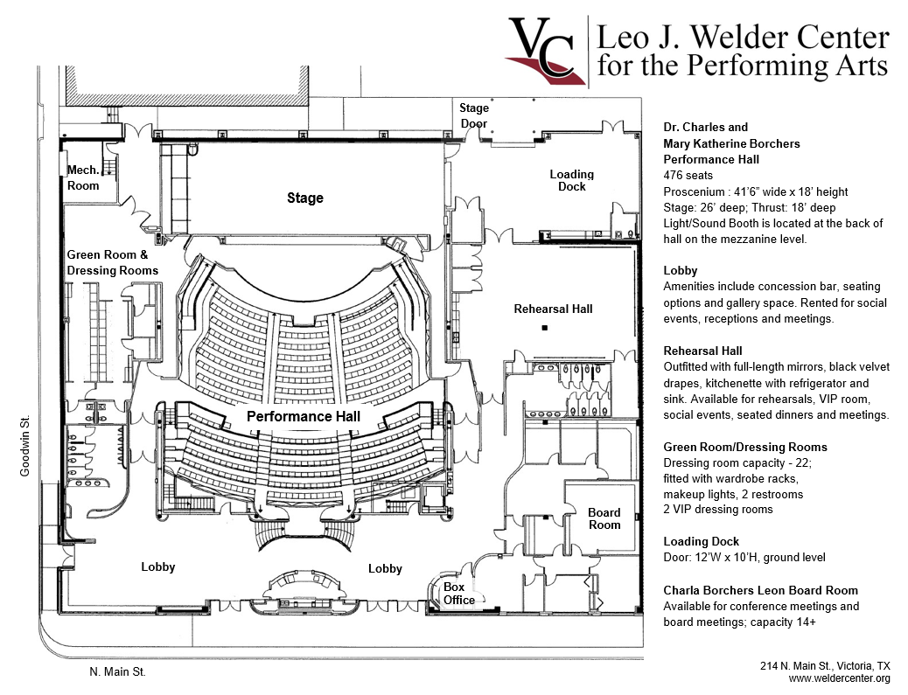

WELDER CENTER Contact
Leo J. Welder Center for the Performing Arts Victoria College, Director of Cultural Affairs 2200 East Red River
Victoria, TX 77901
361.485.8540
Sue Prudhomme, Executive Director of Cultural Affairs sue.prudhomme@victoriacollege.edu 361-582-2436 Melanie Buchhorn, Event Services Planner melanie.buchhorn@victoriacollege.edu 361-573-3291 x3382 Patrick McLaughlin, Production Service Planner Patrick.mclaughlin@victoriacollege.edu 361-572-6475
Ben Hernandez, Administrative Assistant bernardino@victoriacollege.edu 361-580-3738

