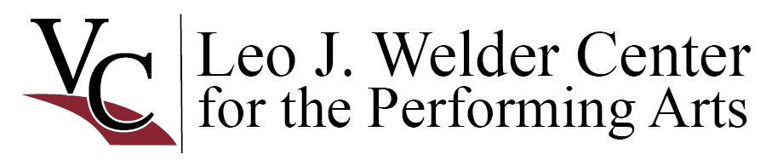
Priority Booking Schedule

LJWCPA Operating Guidelines Section A.1. Booking Priority
The facilities of the Leo J. Welder Center are available for use to all individuals, organizations and corporations on a non‐ discriminatory basis under the terms and conditions set forth in Operating Guidelines and License Agreements. The Welder Center facilities are booked according to the following priority of programs:

- Resident Company Level I – regular season productions are to be requested by Aug. 1 of the preceding year; Welder Center will confirm by Aug. 20. Resident Company may cancel portions of request within 6 months (before Jan. 31) of request date.
- Victoria College Programs – VC Fine Arts dates from previous years will automatically roll to the next academic year, with individual dates to be confirmed by VC Fine Arts by Apr. 1. New Fine Arts events and other VC activities are to be requested between Mar. 15‐Apr. 1 for the next fiscal year; Welder Center will confirm by Apr. 15.
- Resident Company Level I Non‐Season programs and productions, Resident Company Level II, recurring cultural events, recurring Affiliated Organization productions will automatically roll to the next year, with individual dates to be confirmed by the presenting organization by Apr. 1. New dates and/or new events by these organizations are to be requested between Apr. 15‐30 for the next fiscal year; Welder Center will confirm by May 15. The new date/event requests will be processed in the order assigned through a random lottery drawing process.
- Victoria County Non‐Profit and Commercial Arts & Cultural Programs – may be requested on a first‐come, first‐ served basis after May 15; Welder Center will confirm date availability within 15 days.
- Requests received from the above organizations outside of the specified time frame for priority booking will be considered within the priority booking process active at the time of the request. Requests from all other organizations not specified above will be received after June 1 each year and considered on a first‐come, first‐served basis after all prioritized bookings are confirmed.
- Requests as enumerated above should be submitted via the appropriate completed rental reservation form and should include one ideal date request, and one or two acceptable alternate date requests, with as specific timing information as possible, i.e. “Mondays only” or “Spring Break or the week after is not possible.”

This booking schedule may be superseded by formal, written agreements made with Victoria College. Victoria College reserves the right to refuse scheduling of events, activities and performances during certain periods of time when, in the sole judgement of Victoria College, that scheduling may undermine ticket sales or attendance at previously booked events that target the same audience for attendance. Victoria College shall refuse to rent facilities for any event, activity or performance if it determines, in the sole judgement of Victoria College, that such event, activity or performance or the anticipated audience response to such event, activity or performance may cause damage or the unusual risk of damage to the facilities or patrons. Victoria College will refuse to rent facilities if it determines, in the sole judgement of Victoria College, that the event, activity or performance is inconsistent with the college’s mission, vision and values, or the event, activity or performance has the potential to damage the college’s public image. Victoria College reserves the right to change and amend these guidelines at any time. In the event that any of the above deadline or submission dates fall on a weekend or holiday, the next business day becomes the deadline.

Definitions
Interpretation of these definitions is at the sole discretion of Victoria College.

Affiliated Organization – those organizations that are affiliated with the establishing purpose of the Leo J. Welder Center. Affiliated organizations are those whose primary purposes are the establishment, promotion, practice of, or support for performing arts and cultural activities.

Educational program – the schedule of workshops, camps, and academies for youth and avocational participants.

Mission ‐ The mission of The Leo J. Welder Center for the Performing Arts is to provide a facility for the use, enjoyment and education of the Victoria College community and the public that is suitable to the exposition of and education about the performing and other fine arts, including dramatic production, and to further accommodate lectures, workshops and classes relating to the fine arts as well as contain space for rehearsal and display purposes.

Recurring cultural events – those events that are vital to the cultural life of the Victoria community, that have been held for numerous consecutive years, and that have a well‐established audience of 150+ for each performance or presentation.

Regular season – the schedule of productions promoted by an organization as available for season subscription and sold together in an annual subscription package as part of the primary purpose of the organization, and the activities directly associated with those productions that are held for each production (rehearsals, auditions, load‐in, etc.). Non‐season is defined as all other activities of a particular company unless defined otherwise.

Resident Company Level I – an organization that hosts at least 80% of its regular season productions at the Leo J. Welder Center and with which Victoria College has a formal, written agreement.

Resident Company Level II – an organization that hosts at least 80% of its regular season productions at the Leo J. Welder Center; no formal, written agreement is in place. Applies to organizations with 3 or more productions included in their season, or annual festival‐type events encompassing 3 or more consecutive days.

Victoria College Programs – performing arts, Lyceum, cultural, student and administrative events hosted by VC departments or divisions, alone or in partnership with non‐VC organizations. Performing arts, Lyceum, and cultural productions with a projected attendance of 150+ will have booking priority over other VC activities.

Victoria County Non‐Profit & Commercial Arts & Cultural Programs – those programs with performing arts or cultural content hosted by non‐profit or for‐profit organizations whose registered place of business is Victoria County.

www.weldercenter.org 214 North Main Street, historic downtown Victoria, Texas
Owned and managed by Victoria College Mailing Address: 2200 East Red River, Victoria, TX 77901

