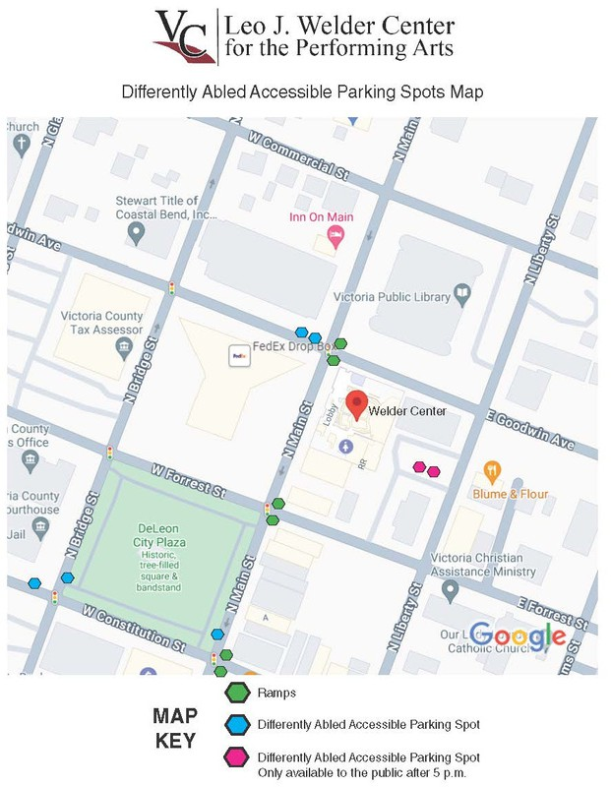

Directions
There are two differently abled accessible parking spots located in the back parking lot of The Leo J. Welder Center for the Performing Arts off N Liberty St. These spots are only available to the public after 5 p.m.
There is one differently abled accessible parking spot facing DeLeon City Plaza near the corner of N Main St. and W Constitution St.
Near the corner of N Bridge St. and W Constitution St., there is one differently abled parking spot. This spot is also facing DeLeon City Plaza.
Near the spot facing DeLeon City Plaza off N. Bridge St., in front of Victoria County Courthouse and off of W Constitution St., is another differently abled accessible parking spot.

