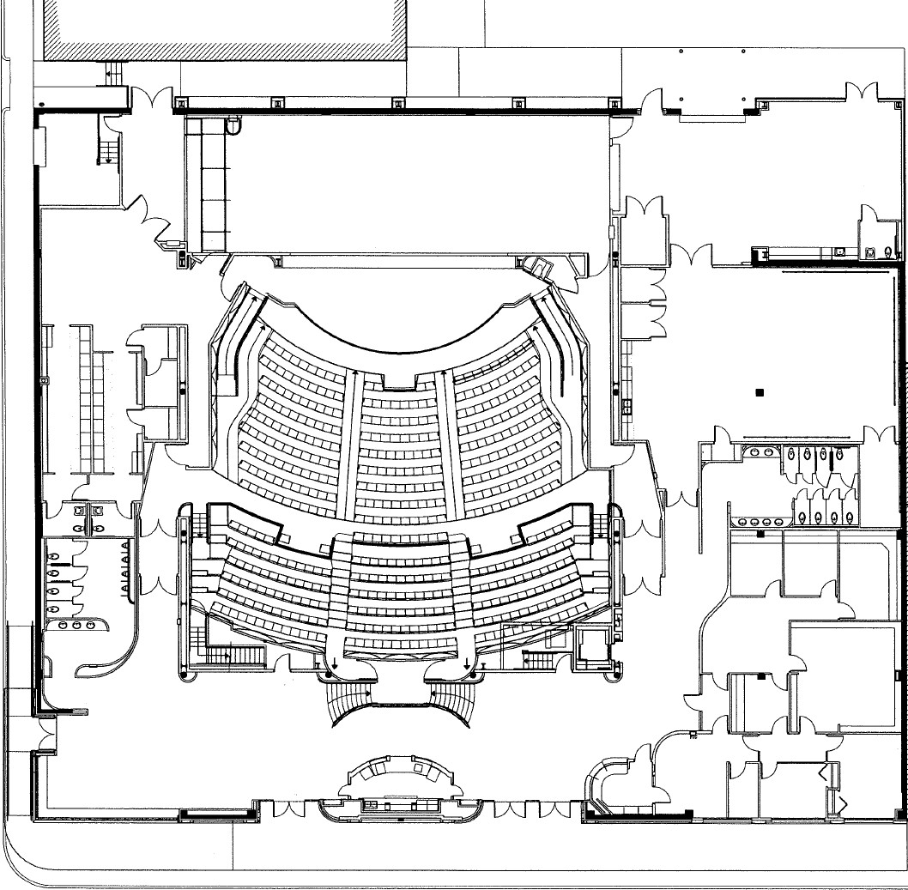

Goodwin St.

Mech. Room
Stage Door

Stage

Green Room & Dressing Rooms

Performance Hall

Lobby

N. Main St.

Loading Dock

Rehearsal Hall

Board Room
Box Office
Lobby
Dr. Charles and
Mary Katherine Borchers Performance Hall
476 seats
Proscenium : 41’6” wide x 18’ height Stage: 26’ deep; Thrust: 18’ deep
Light/Sound Booth is located at the back of hall on the mezzanine level.

Lobby
Amenities include concession bar, seating options and gallery space. Rented for social events, receptions and meetings.

Rehearsal Hall
Outfitted with full-length mirrors, black velvet drapes, kitchenette with refrigerator and sink. Available for rehearsals, VIP room, social events, seated dinners and meetings.

Green Room/Dressing Rooms Dressing room capacity - 22; fitted with wardrobe racks, makeup lights, 2 restrooms
2 VIP dressing rooms

Loading Dock
Door: 12’W x 10’H, ground level

Charla Borchers Leon Board Room Available for conference meetings and board meetings; capacity 14+

214 N. Main St., Victoria, TX www.weldercenter.org

